Latest News
Tuesday 21 Mar 2017
From: Michael Fonfe
Received by: Email.

February saw our first Expat Volunteer from the UK come out “to see the Project and do what I can to help”. Anna Irvine is an English Teacher as well as a Swimming Teacher and joined us over the February Half Term to help with a Crash Course. Rather than say ‘she did this or that’, I thought it would be much more interesting to hear about the Project from Anna’s racey account in her own words. Thank You, Anna, for your effort and for taking on board why we teach people to float first, then swim. I hope the experience leads you to run your own show, saving lives by teaching swimming. Good Luck.

Teaching ‘Swimlish’ in Sri Lanka With Anna Irvine

My work means I’ve been lucky enough to teach English, live and swim on islands like Sicily and Sardinia. So the decision to relocate to the UK, albeit to an international setting, was tough. What would happen to my waterlust? Would it sink and take with it my adventurous side?

I figured volunteering abroad would mean I could develop my swim teaching and help others. Weaving the swim teaching and volunteering strands together wasn’t immediately awash with straightforward aquatics opportunities in the UK. But, somehow, through my research, I find the SriLanka Women’s Swimming Project’s website.

Reading the statistics on Icanswimcanyou.com , I realise swim volunteering isn’t about the finer points of the breaststroke glide, but would concern education in drowning prevention strategies. I am informed that in Sri Lanka:

- Swimming is not a universal skill;
- The mindset is ‘Keep away from water or you will drown’
- After the 2004 tsunami, 80% of those who drowned were women and children;
- Some women ‘s deaths were attributed in part to culture and also to couture. Concerned about immodesty, some women, whose garments were removed by the first tsunami wave, refused to come out the water and drowned later waves,;
- Up to 3 people every day still continue to drown on the beaches, lakes and rivers of Sri Lanka;
- More Sri Lankans drown than die of dengue fever but drowning is not recognised as a public health issue.

Despite my skills being more geared to competition than survival, Christina Fonfe, BEM, the charity’s Director, did accept my application. She had seen something in my skillset that was of value to her Project. This was not the last time I heard of, or experienced, Christina’s uncanny knack of transforming challenge to opportunity.

A month or so before departure, I receive a mail, with my week’s duties outlined. In addition to teaching 18 hours of swimming, I am expected to teach 10 hours of English as a Foreign Language (EFL). I’d applied for a volunteership role 8,185 miles away when I could experience English teaching in my classroom a 10-minute commute from home.

Yet, the more I learnt about the Project, the more teaching Swimlish made sense. Preventing drowning through teaching women and teenage girls to swim, ensures that they, in turn, can teach their own children and families. What’s more, the best are trained as swimming teachers to international standards using English and provides an immediate micro-economy benefit and elevation of social status to those women in the community. This closely fits with the UN’s Millennium Goal, outlined in 2015, to Promote Gender Equality and to Empower Women.

Vinila is one such success story; a non-swimmer who has mastered the finer points of bilateral breathing and, who not only teaches swimming but also runs the programme at its Ahangama HQ. Her skillset would be the envy of any leisure centre manager, ranging from pool maintenance to recruitment. And all this alongside roles of wife and mother. English lessons would support Vinila in extending her students’ knowledge of Swimlish and facilitate communication with Christina.

The sun is a scorching 40 degrees; our first class of women arrive for their ‘5 Day Crash Swimming Course’ wearing colourful western clothing or traditional saris. Vinila meticulously records attendance and checks each woman’s Passport to Swimming (more on this later). The swimmers use the changing rooms to get into costumes, leggings and swimming hats, before taking a cooling shower overlooking the balustrade separating the centre’s palm-fringed lawn and swimming pool from the Indian Ocean. “Is it safe to swim?”, they ask before entering the water. Later, the importance of this question will keep me awake at night.

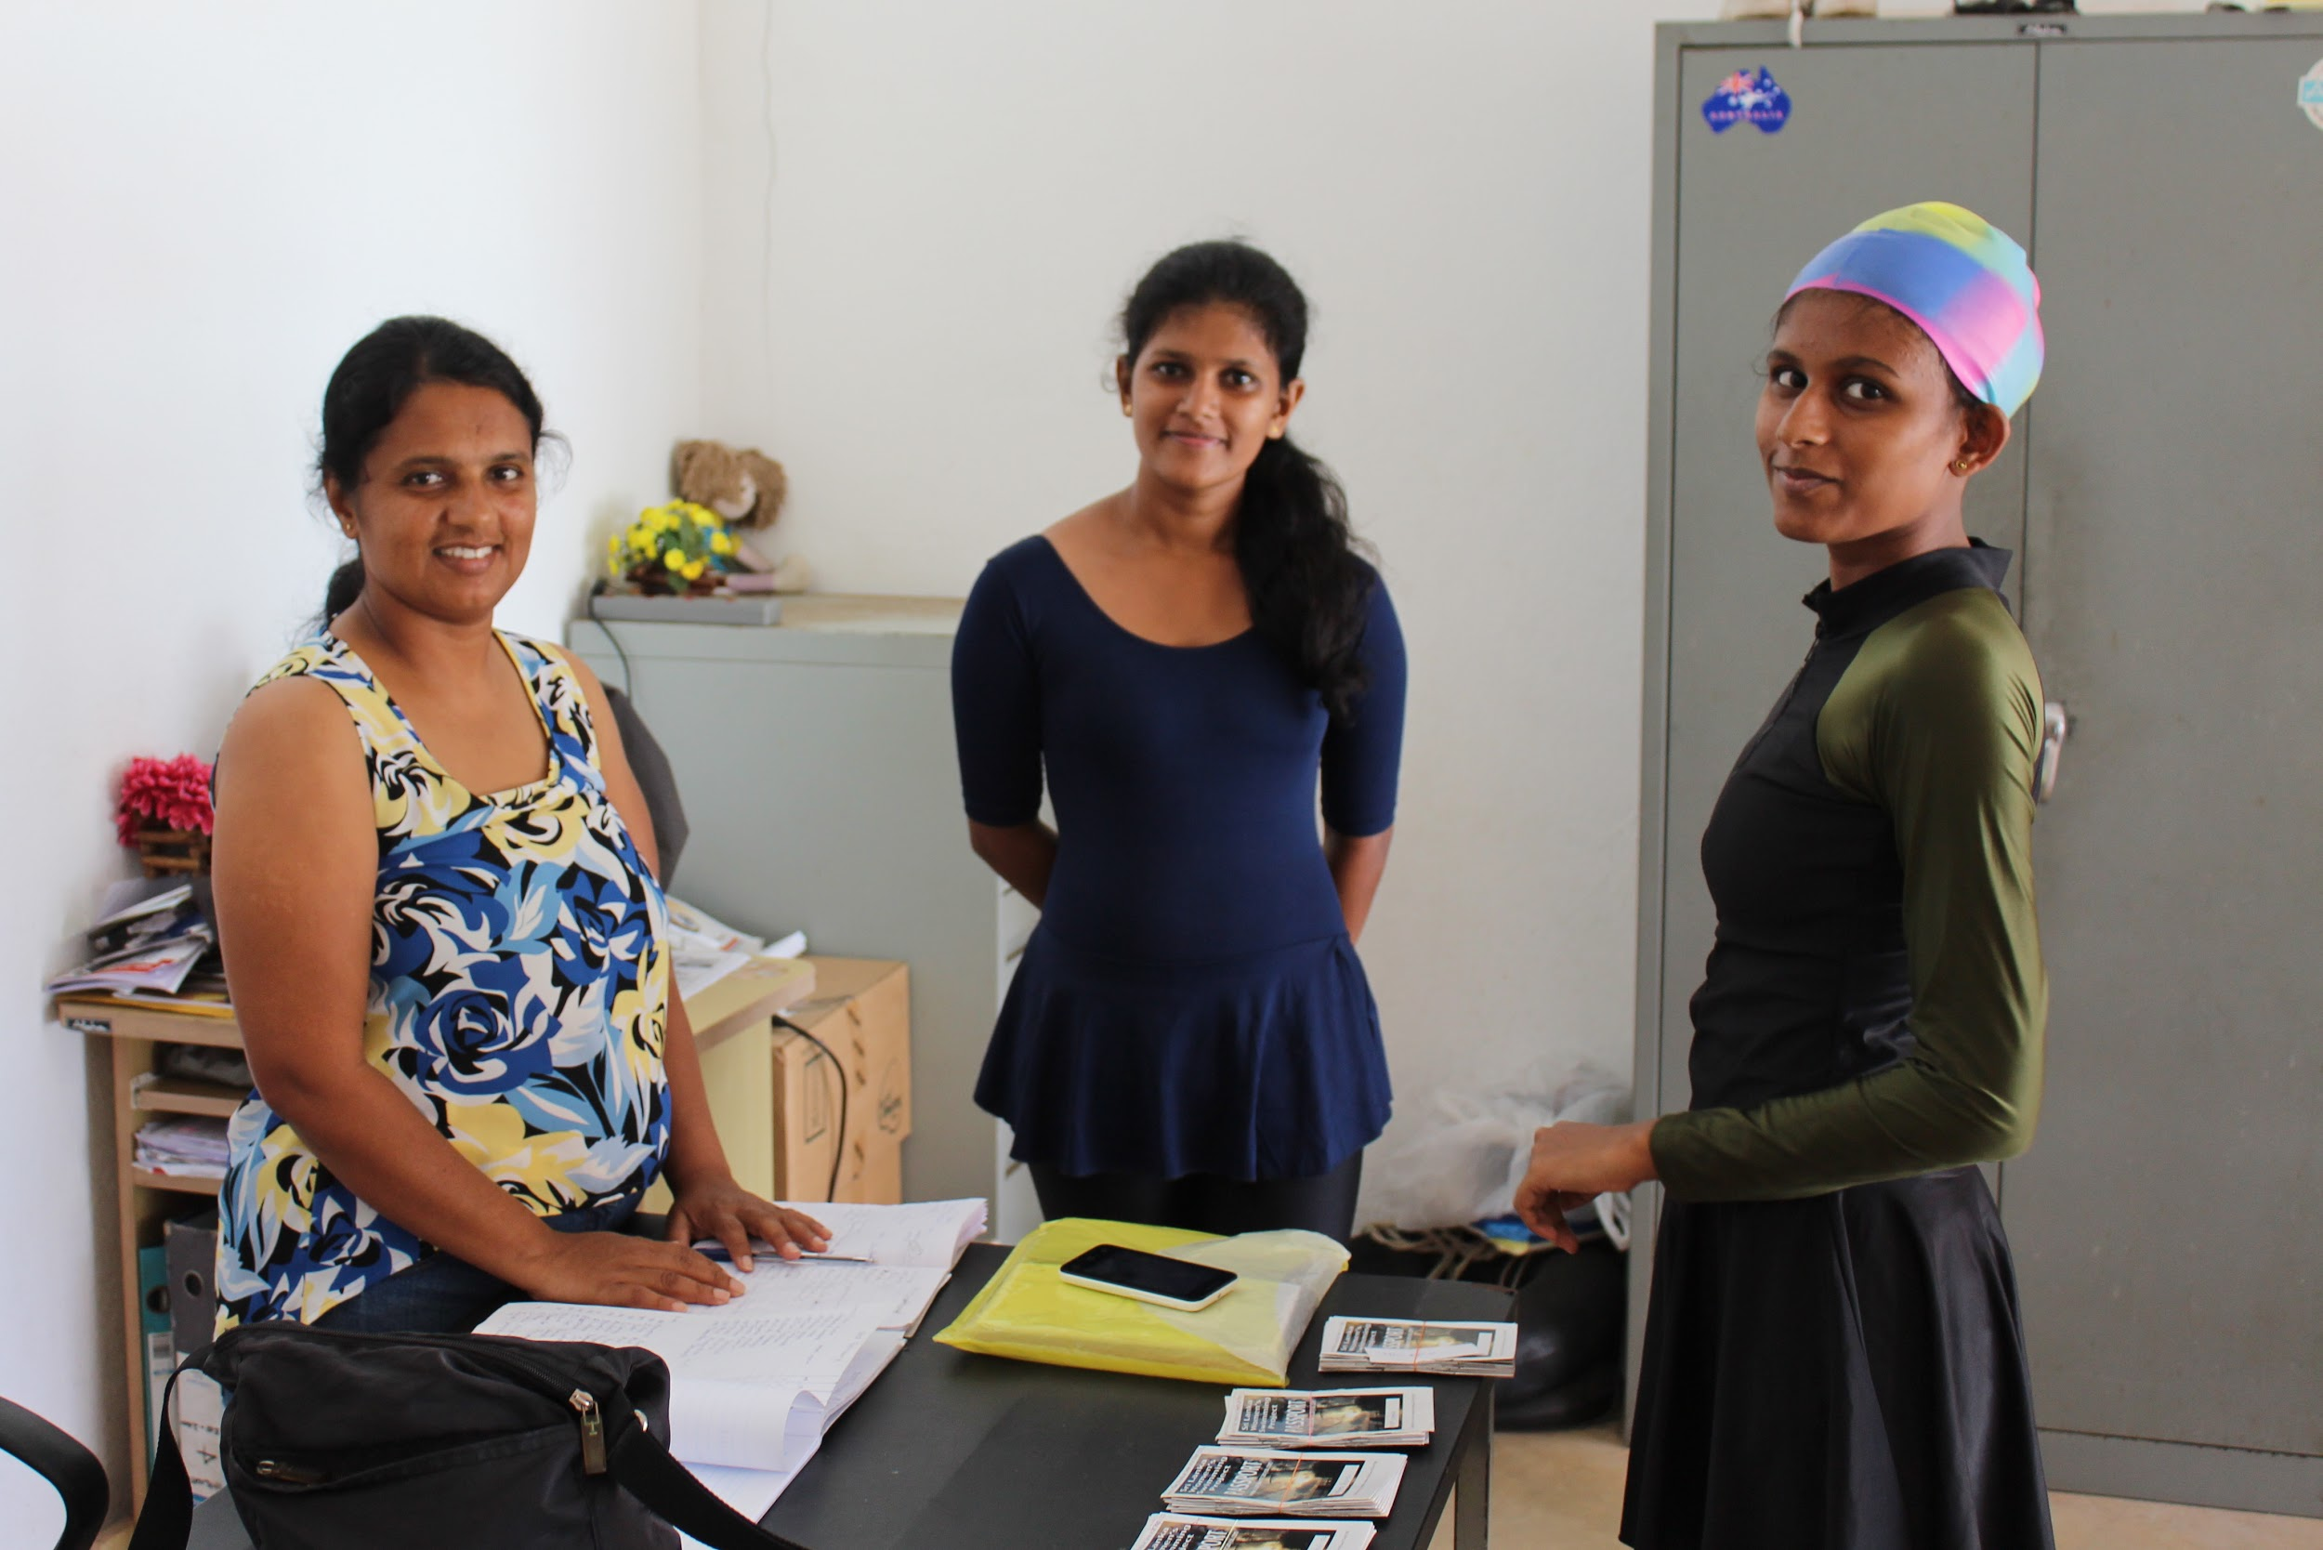
Caption: Vinila, left, takes the Register and checks the Passports to Swimming

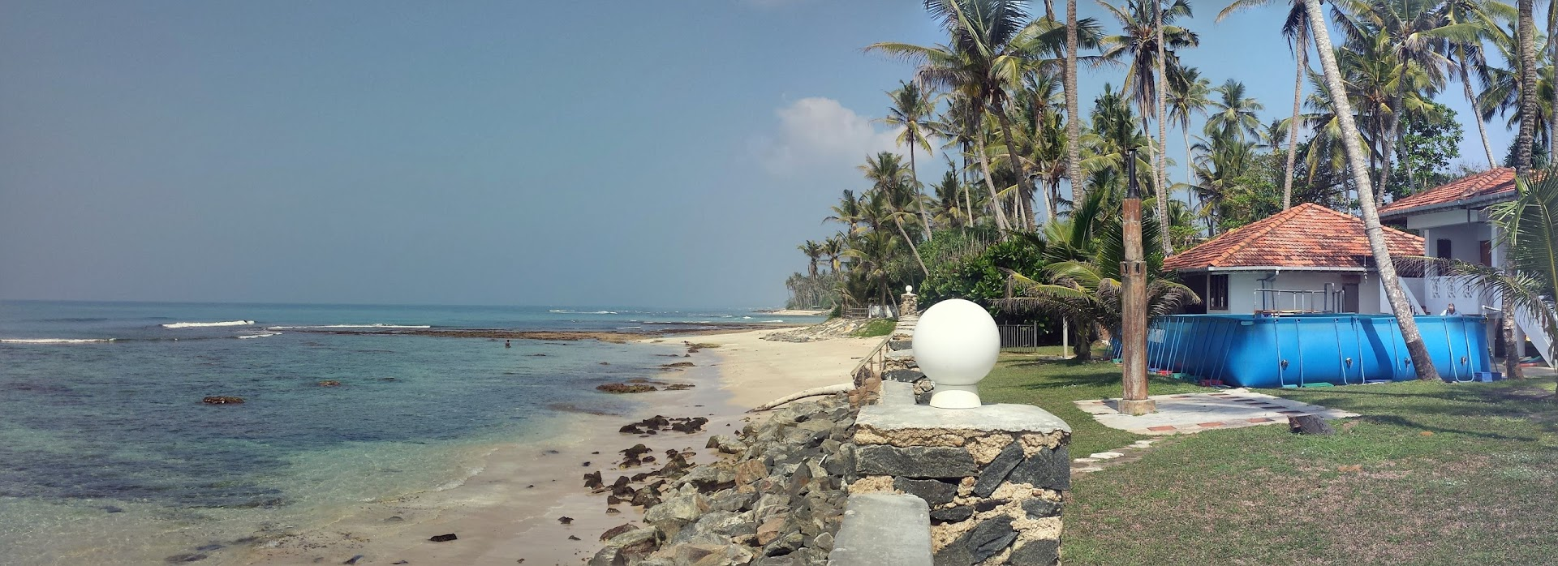
Caption: Looks like paradise, but you can’t see the pooh or the rip current…

Always ask a local whether the water is safe to swim in; never swim alone; always swim in clear water: Golden Rules shared with me on the first day. By Day 3, more confident of my surroundings, craving exercise and not wanting to disturb my hosts, I foolishly decide to have a dip in nearby bay at the end of the strip of coast: I can’t resist the lure of white sands and sparkling surf. Wet hair a giveaway, I admit it when I get home but figure no harm done. It is then that my host shares the bay’s dark secret. As the salty drips slide down my back, he informs me that the water is unclean with effluent centrifuging before sweeping back out to sea and, that it was there, on New Year’s Day, that an ‘I’m a good swimmer’ tourist was dragged outside the reef and drowned.

That night, I lie awake, staring at the ceiling. The dichotomy between swimming as sport and swimming as drowning prevention crystalises. The sea is no longer a playground but a force of nature to be treated with respect. Our swimmers are those who may have lost friends and relatives in the tsunami or, through drowning in the many rivers, pools, ditches on the island. Yet the humiliation and fear I’m experiencing is only a fraction of that which the swimmers are filled with when taking to the water the first time. And thanks to my misadventure, the value of the Project appreciates and I begin to love it a little bit.

Christina’s teaching method deals sensitively with these cultural, historical and psychological factors. In a discreet setting, away from any male eyes, our female students are first taught how to float-and-breathe, then how to swim. Research indicates that floating and breathing should be the immediate reaction to sudden unexpected immersion in water. Once floating on your back, you can catch your breath and call for help. I notice Christina’s swimmers rolling onto their backs to float if fatigued or struggling. When ready, they flip over to their front, coolly returning to their swimming practice.

Thanks to Project, over 6,000 women have challenged the prevailing view of swimming as frivolous and have accepted its relevance to saving their lives. They have improved their drowning survival odds and overcome fears of immodesty and have acquired a whole lot of confidence and self-esteem building on the way. A smaller, yet significant number have freed themselves from the poverty trap. One star pupil, Indu, has recently graduated as an Attorney at Law from the University of Colombo. Her university application was strengthened by the hard work she put into gaining her STA swim coach qualification, almost unheard of in Sri Lanka for a female, alongside her proficient level of English.

Vinila and Indu have reached and exceeded all the Passport milestones on their journey into water. The passport booklet records the thirty skill steps of a course to take an absolute beginner to be a competent, safe swimmer. It’s a document that Chris has developed over forty years of honing her craft. On Days 1 and 2, instruction takes places on a one-to-one basis.

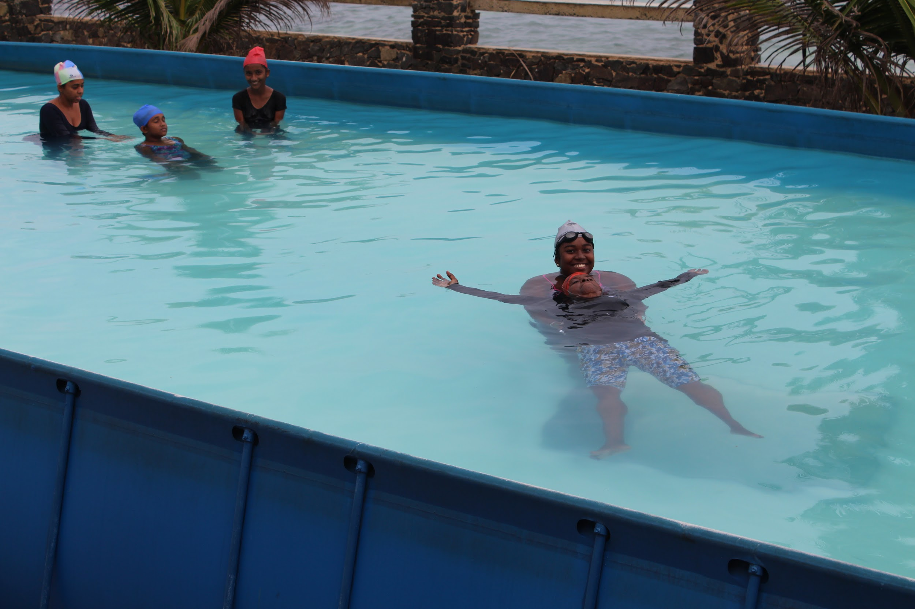
Caption: All it takes is the discovery that if you relax
and balance on your back, you can breathe freely.

Learning is fun, with exercises like shouting your name underwater and monkey walking, arms swinging like an orangutan, building confidence. By Step 30, Chris’ swim teachers slice gracefully through the water, perfectly balanced and breathing bilaterally, so their continuous motion is fluid. I think back to my learners, who equate splash with speed, and to how they would benefit from these techniques.
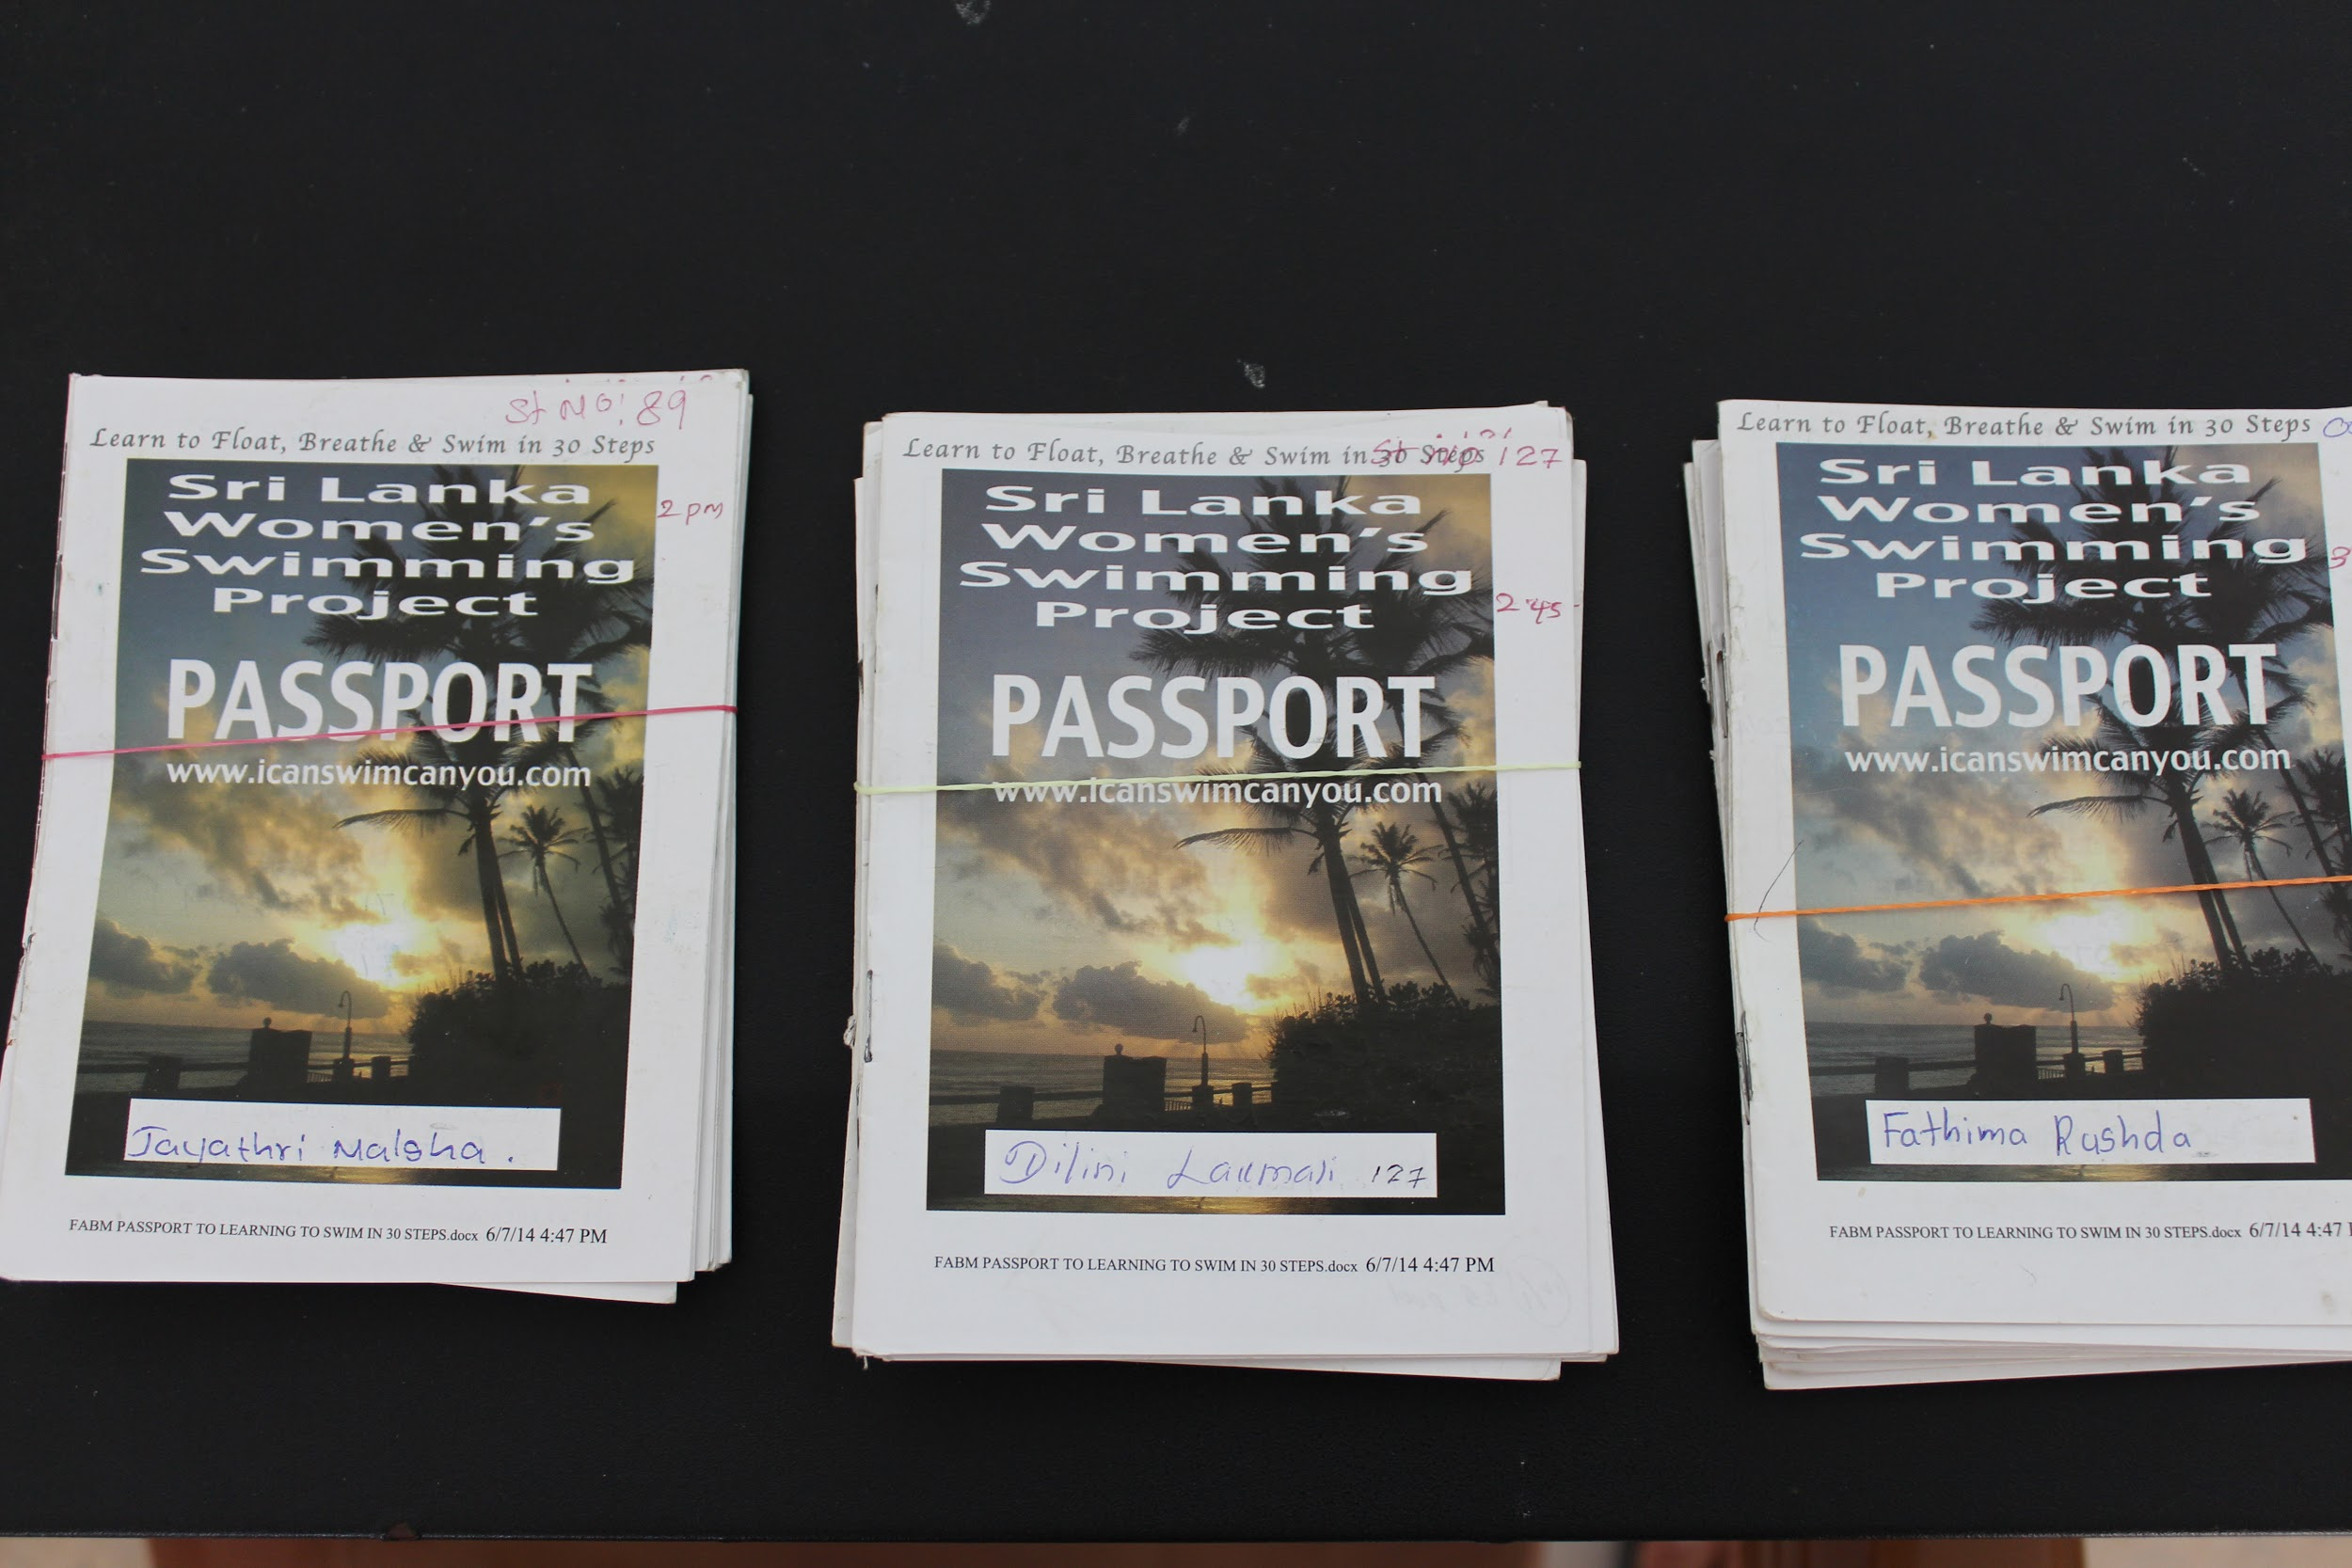
On the final day of the course, we celebrate the beginners’ achievements. Of the group, some have gained their ‘I can Survive One Minute Award’ : able to swim 10 meters and float for 1 minute; others their ‘‘I can Survive Two Minutes Award’ : swim 25 meters and float for 2 minutes. (The magic words ‘I can SWIM’ do not get used until the float lasts for Ten Minutes and the Distance is 100 metres.) (Mike adds: When they can do that, they have a Passport to any Swimming Pool. If they want to swim in the sea, they need a Beach Visa, which requires much more instruction, beach swimming exerience and higher survival standards). The session finishes with a game involving spelling the first letter of a name in English using your arms and legs. Once dry, and, still laughing, we are warmed up by a hot cup of sweet, milky Ceylon tea. The relaxation, joy and sense of fortitude that comes from being in the water glows on our faces. We are sharing a worthwhile endeavour and know we are looking after ourselves and one another. Chris remarks that the Project likes its parties and I sense a playful side to her, despite the weight of responsibility she shoulders for Sri Lanka’s women.
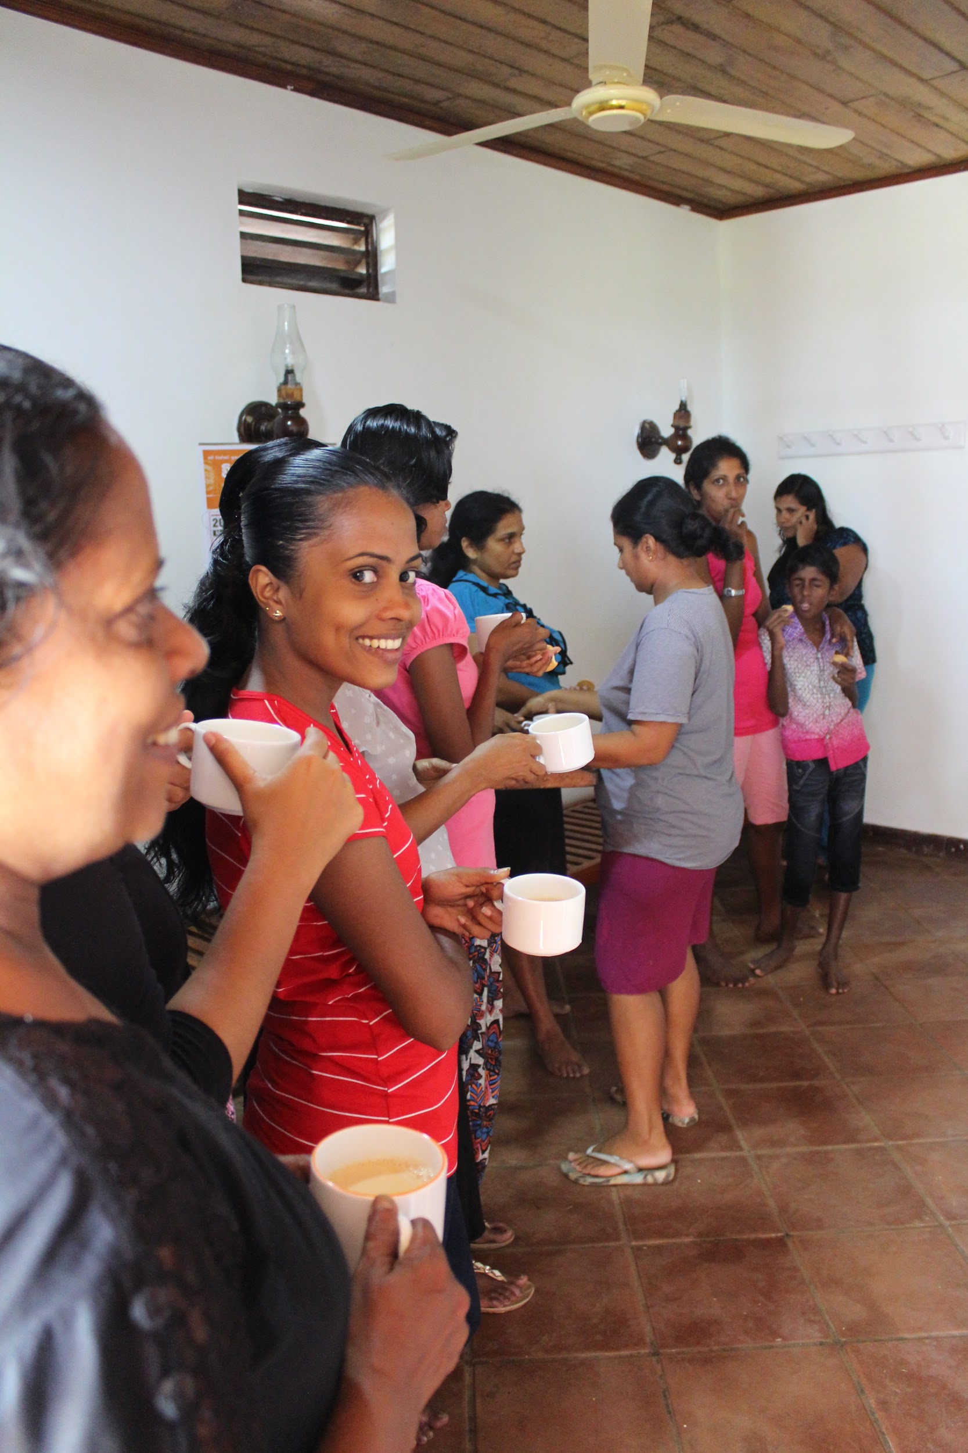 Caption: The women who can now swim ooze confidence and self-esteem as they sip their traditionally thick, hot ,milky, sweet tea.
Caption: Now that we can swim and speak English, our smiles celebrate the achievement.

3. divakalala, c (2009) after the Waves ibSn 978-955-1772-33-8 in Search of Women’s narratives p. 199.
http://www.worldconferenceondrowningprevention2011.org/SiteMedia/w3svc1092/Uploads/Documents/WCDP2011_Swim&WS_Fonfe_p208_Abstract.pdf
http://www.worldconferenceondrowningprevention2011.org/SiteMedia/w3svc1092/Uploads/Documents/WCDP2011_Swim&WS_Fonfe_p208_Abstract.pdf
https://www.womenandchildrenfirst.org.uk/sdgs-and-mdgs?gclid=EAIaIQobChMIqM2X763b1QIVxp3tCh2C2AHyEAAYASAAEgLlAPD_BwE
4. Stallman, rK, Junge, M, blixt, t (2008) teaching Swimming based on a Model derived from the causes of drowning. international Journal of aquatic research. 2(4), pp. 372–382. 5. connolly, J (2006) irish Lifesaving foundation www.lifesavingfoundation.ie

